Diane Kaplan
CSCI E-58
Bioinformatics Algorithms
April-May, 2015

Project writeup: Finding Intron Splice Sites
(For bigger/clearer images, view directly here: https://docs.google.com/document/d/1YP93GUDvJ1JsVB4YRnRfhEoF0Tz9E9OCwkhwUEgJLqk/edit?usp=sharing)

1) Problem Overview
Being able to correctly identify introns in a sequence and strip them out is one of the critical first steps in being able to interpret the genome. Getting this right is the key to recognizing the sequence’s codons, the translated proteins, and the greater function.

This challenge appealed to me for my project topic as an extension from our tata boxes problem: to be able to find something important in a sequence, but this time where what we’re looking for is somewhat fuzzy, as opposed to a literal match.

There are tools available to find and score splice sites (mentioned in my presentation)- I have a great appreciation for the difficulty of the task they’re solving, and gratitude that I can approach this problem with the enormous luxury of being able to check my results as I go.

2) What I did
The functions I wrote to help with this goal live in find_splice_functions.py. They are:
evaluate_motif: Take a short string you're testing and a type of motif (donor or acceptor. Return its probability as this motif if higher than happening by chance, otherwise return false

find_motif: Take a sequence and find a list of potential splice sites. User specifies donor or acceptor so this function can be used in conjunction with functions that check the landscape for whether it's likely
def find_motif(seq, motif_type):

get_winner: Take a list of lists for the splice sites identified, and return the one with the highest probability. We assume the list-of-lists returned by the find_motif function above, where each list's element 2 is the score.

make_clean_seq: Take a sequence, list of donor sites, and list of acceptor sites, and return sequence with introns removed. From the earlier functions, we'll assume the same format (list-of-lists) for donor sites and acceptor sites.

find_change_points: Take a big long sequence (covering multiple exons/introns), and look for changes in base frequencies to find a list of general change points. This list includes whether it’s a suspected donor or acceptor, and it’ll guide us in where to look for our splice site motifs.

put_it_all_together: Take a sequence, and use find_change_points to identify which chunks to pass to find_motif.

How they work end-to-end:
The user calls put_it_all_together with a sequence containing introns, and gets back a sequence with the introns stripped out.

put_it_all_together calls the others like this:
- It calls find_change_points, to get the rough area of each splice site
- For each of these areas, it calls find_motif with the appropriate value (donor vs acceptor), to find qualifying candidates for that motif in that chunk
- Then it calls get_winner to choose the best in each list. I left this separate (instead of just having the function above return the best one) since we’ll commonly want to be aware of alternate splice sites, especially if the scoring in find_motif isn’t lining up consistently with the correct results
- It puts the known/winning splice locations into lists (one for donor sites and one for acceptor sites), and it calls make_clean_seq with the original sequence and those lists, getting the clean one back in return.

Results:
I’ve included two files to exercise these functions. Here’s their output:

exercise_splice_finding_functions.py
This was where I tested evaluate_motif (it’s actually called by find_motif) for seven sequence samples (having at most one of each acceptor site), and comparing my results with the Human Splicing Finder tool. Here’s a comparison for exon 3 of the CDK10 gene- first the results from Human Splicing Finder: :
- go to http://www.umd.be/HSF3/HSF.html
- For analysis type, choose “Analyze a sequence”. (“Splice site analysis” also works, but the numbering starts from the start of the exon rather than the start of the overall sequence)
- For Choose a sequence, select “Gene name”

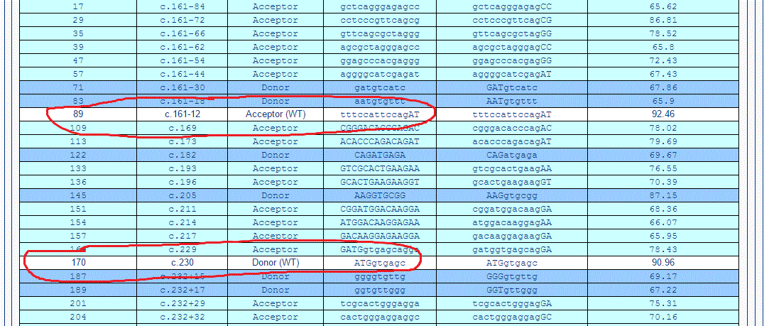

And here from exercise_splice_finding_functions.py:
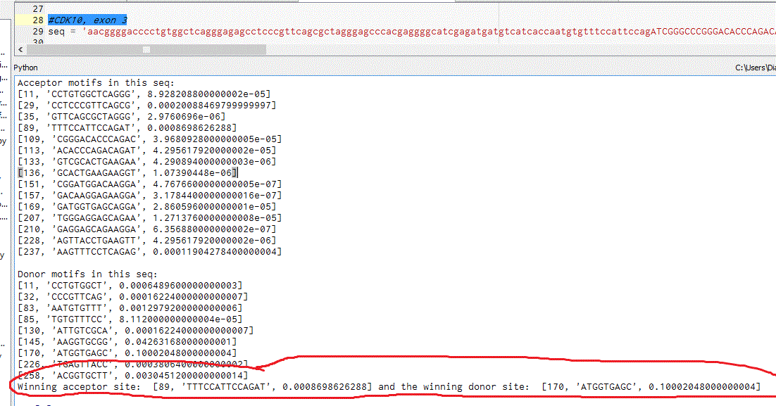

exercise_whole_sequence_functions.py
This was where I tested:
- put_it_all_together: using sequence example with CDK10 sequence including exons 1-3
- make_clean_seq: using alphabet example, to be able to show it a little more granularly

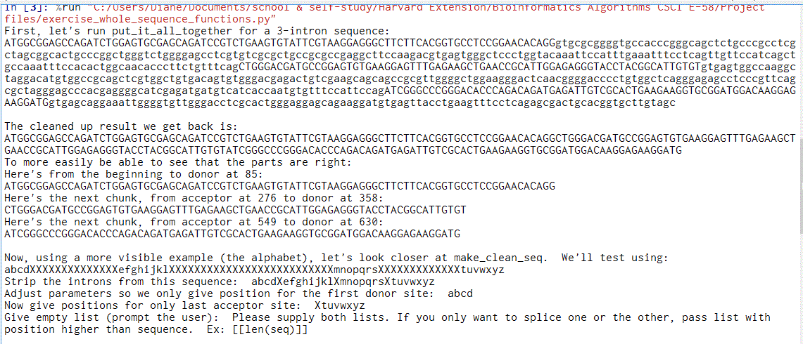
List of remaining issues:
- evaluate_motif: this gets both correct sites for 5 of the 7 samples- (and adding weighting after last week’s presentation fixed one known problem case). I spent a little time down the path of identifying a minimum score threshold, but it was a dead end; I had winners in some results with lower scores than losers in others. Therefore for my demo above that showed a multi-exon sequence, I used a sequence of the CDK10 gene, including exons 1-3. (But if I also include exon 4 it correctly finds the acceptor site, but not the following donor site).
- find_motif: none- all set
- get_winner: none- all set
- make_clean_seq: none- all set
- find_change_points: It was important to me to try the more vast task of picking out the right chunks to look in within a larger, multi-exon sequence, even knowing that I’d likely run out of time. I looked into several approaches- (hexamer content as mentioned in the presentation, base frequency)- the most direct first step was the base frequency: before-vs-after donor sites, C&G frequency go down and T goes up, and the reverse is true for acceptor sites. Therefore this function looks at 25bp bunches and checks for rises/drops in base frequency. It does detect changes in the ballpark of the known splice sites, but the results included an extra site, and the positions are really questionable. One factor could be how early/late in that 25bp chunk the splice site appears (resulting in a lag before the changed percentage is ‘observed’), but honestly it’s more likely just not enough to correctly determine these sites yet. I chose a small window since exons can be as short as 30bp (and I’m reluctant to compromise too much on sensitivity), but even when I try adjusting that size the results are no better, so until I get it working better I added a line in the put_it_all_together function to update/stub the chunk_locations_list with correcting winning locations.
- put_it_all_together: none- all set
After fixing the remaining bugs, I want to go through the process of looking how to speed up my functions (just for having that experience; so far they return results quickly for the small sequences I’ve tried). The mission I’d given myself was to be able to find and clean introns from a big sequence, and in the end that was big enough (and I’m green enough) that there was only time to approach the two difficult steps in a cursory way. Another approach would have been to keep my focus to only one step- (ONLY evaluate_motif or ONLY find_change_points)- and get that aspect working fully. In retrospect, that probably would have been more in keeping with the spirit of the course (definitely the title), so I’ll continue with that on my own.

3) What I learned
The obvious one is that I’ve learned quite a bit about the particulars of intron splice sites in my reading and in the testing I’ve done. The bigger lesson for me is probably one that all new developers go through. This class and the last one have guided me through a lot of new concepts and given me a new toolbox to explore them. In this topic of finding splice sites, there has been a ton of research and discoveries to providing potential clues that I could follow in my approach to this problem, but without having much contextual experience to gauge how relevant and feasible these clues are to explore, I repeatedly ended up in a state of a lot of reading (and waffling) that would probably have continued longer if not for the looming deadline. That time constraint was absolutely a blessing; it turned this into a great exercise in pragmatism and prioritization, first at the level of breaking out the pieces I needed, then as a way to choose which items off my mountainous to-do list to take next, and how long to give them before moving on. Since that mental switch I’ve gotten more accomplished in recent weekends that I would have dreamed (especially given work and family obligations during that time), so if I’d found a way to zero-in sooner on my topic, it’s exciting to think about how much further I might have gotten. (Instead that’ll have to continue on my own). Thanks for all of your help and suggestions along the way!

References

1 Robert W. Carter. Splicing and dicing the human genome. Creation.com (July 1, 2010).

2 Kai Wang et al. The strength of intron donor splice sites in human genes displays a bell-shaped pattern. Bioinformatics Volume 27, Issue 22, Pp. 3079-3084 (September 5, 2011).

3 Laub, MT and Smith, DW.Finding intron/exon splice junctions using INFO, INterruption Finder and Organizer. Journal of Computational Biology;5(2):307-21(1998).

4 Louie, Elizabeth et al. Nucelotide Frequency Variation Across Human Genomes. Genome Research; 13(12): 2594-2601 (December 2003).

